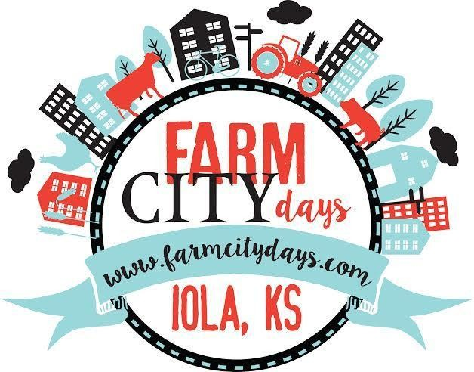52nd Annual Farm City Days Parade

# Saturday, October 21st, 2023 11:00 am Iola, Kansas

**Visit us at www.farmcitydays.com and Like us on Facebook**

# Parade Rules and Regulations:

**-Check In (9:00am) -** You will check-in at the corner of Jeﬀerson and Lincoln. There you will receive the number that corresponds with your description entry. Please place this number on your passenger side

window so it can be read clearly by announcers.

**Line Up/Route -** You will not line up in numerical order. You will check in and be told where to go. Parade will start at **Jeﬀerson and Monroe St**., travel South on Jeﬀerson St., West on Madison St., North on Washington St. and ends on Monroe St.

**Please Note:** *You are ALLOWED to throw candy from your vehicle, although we prefer that you use a walker to throw it.*

**\*\*\*\*\*Entry Form Deadline:** Please return completed forms to: Farm City Days PO Box 751 Iola, KS 66749 by Monday, October 1, 2023. If not received by deadline, you will be added to the end of the parade.*****



**BRIEF DESCRIPTION OF ENTRY: (This will be read by announcer so PLEASE PRINT LEGIBLY)**

## Type of Entry: (ie. Band, Float, Vehicle, Street Entertainer, Farm Implement, Walking Troop, Horse, etc.)

**Overall Length (including tow vehicle and/or number of people):**  ***Release of Claims:*** *My signature indicates that I have read the information provided on this form and understand it fully, that I, and the organization or business I am representing cannot hold Farm City Days, its*

*steering committee, volunteers, and any group aﬃliated with Farm City Days liable for any incidents, damages,*

*losses, accidents, or thefts that may occur to me, my organization, or business during this event.*

## Signed: Date:

**Questions? Please contact us at:** [**farmcitydays@gmail.com**](mailto:farmcitydays@gmail.com)  **or Jerad at 940-395-5282.**