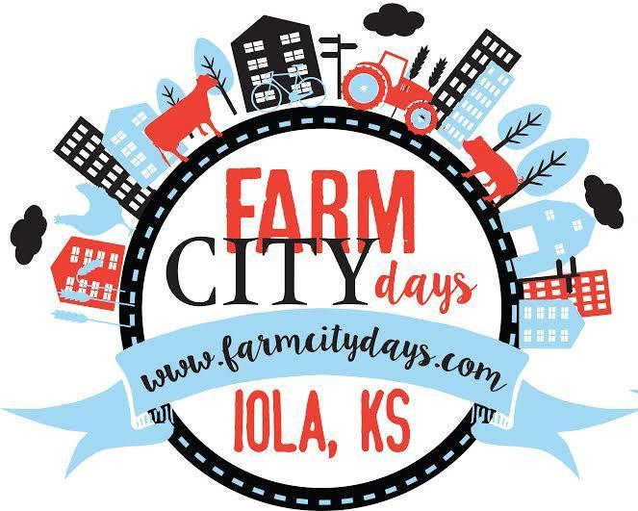Please place a check-mark next to the tier of choice.
Annual Farm City Days Celebration October 16th-17th, 2026 - In Downtown Iola, KS
Sponsorship Form

Complete the information below.

Contact Name ______________________________________

Sponsor Name ______________________________________
Address __________________________________________
________________________________________________
City, State, Zip

Phone: ______________________________________

Email: _______________________________________
Make checks payable to and send form to:
Farm City Days
P.O. Box 751
Iola, Kansas 66749

Please direct questions about: tax deduction verification forms, sending pictures of Logos , ect.. to farmcitydays@gmail.com.
Thank you for your support!
Tier 1 = up to $99.00
- Individual or Company name on FCD website sponsor page.
Tier 2 = $100.00 -$249.00
- Individual or company name on FCD Print publications.
- (1) Official Farm City Days gift
- PLUS tier 1 benefits
Tier 3 = $250.00 - $499.00
- Individual or company name on display during FCD events
- (1) FCD Sponsor T-Shirt
- PLUS tier 1 and 2 benefits
Tier 4 = $500.00 - $999.00
-Individual or company name printed on T-Shirts
- Company name printed in advertisements
- Radio Mentions
- (2) FCD Sponsor T-Shirts
-PLUS tier 1-3 benefits
Tier 5 = $1,000.00 - $2,499.00
- Individual or company name announced at live events
– Parade Trophy Sponsor
- (4) FCD Sponsor T-Shirts
- PLUS tier 1-4 benefits
Tier 6 = $2,500.00 - $4,999.00
- Event Sponsor
- Free Vendor Booth

- Medallion Hunt Sponsor
- (6) FCD Sponsor T-Shirts
-PLUS Tier 1-5 benefits
Tier 7 = $5,000.00 and above
- Ride on the Rainmaker Float
- Grand Champion Trophy Sponsor
-(8) FCD Sponsor T-shirts
- PLUS tier 1-6 benefits

Numbers in ( ) do not accumulate. PLEASE LIST SHIRT SIZES!!

